Sleeping pills could DOUBLE risk of this dangerous fracture - are YOU at risk?

SLEEPING pills - medications that encourage sleep - could double the risk of breaking or fracturing a hip, new research has revealed.

By [OLIVIA LERCHE](http://www.express.co.uk/search?s=%20Olivia%20Lerche&b=1)

09:48, Thu, Apr 27, 2017 | UPDATED: 10:31, Thu, Apr 27, 2017

|  |  |  |  |  |  |  |  |  |  |  |  |  |  |  |  |  |  |  |  |  |  |  |  |  |  |  |  |
| --- | --- | --- | --- | --- | --- | --- | --- | --- | --- | --- | --- | --- | --- | --- | --- | --- | --- | --- | --- | --- | --- | --- | --- | --- | --- | --- | --- |
| |  |  |  | | --- | --- | --- | |  | http://cdn.images.express.co.uk/img/static/comments/newshare/fb.png |  | | |  |  |  | | --- | --- | --- | |  | http://cdn.images.express.co.uk/img/static/comments/newshare/tw.png |  | | |  |  |  | | --- | --- | --- | |  | http://cdn.images.express.co.uk/img/static/comments/newshare/g-plus.png |  | | |  |  |  | | --- | --- | --- | |  | http://cdn.images.express.co.uk/img/static/comments/newshare/m.png |  | | |  |  |  |  |  | | --- | --- | --- | --- | --- | | |  |  |  | | --- | --- | --- | |  | http://cdn.images.express.co.uk/img/static/comments/newshare/sh.png |  | | **11** | | |  |  |  |  |  | | --- | --- | --- | --- | --- | | |  |  |  | | --- | --- | --- | |  | http://cdn.images.express.co.uk/img/static/comments/newshare/c.png |  | |  | |

GETTY

Sleeping pills: Taking the drugs can increase hip fracture risk

Older people newly prescribed sleeping pills like benzodiazepines and ‘Z-drugs’ have over double the odds of a [hip fracture](http://www.express.co.uk/life-style/health/664922/hip-replacement-patients-less-likely-to-have-operation-poor-deprived) in the first two weeks, scientists have found.

Experts have said there is a 53 per cent increase in risk for people taking the medication for more than two weeks.

[Sleeping](http://www.express.co.uk/life-style/health/708460/seven-causes-headaches-symptoms-dehydration-sleep) tablets are prescribed if people suffer severe insomnia or as a short term measure to ease symptoms of insomnia.

However, experts have warned of the dangers of the drugs as they can cause side effects - such as drowsiness the following morning, which can lead to falls.

RELATED ARTICLES

[[](http://www.express.co.uk/life-style/health/780003/heart-disease-symptoms-mattress-sleep-link)](http://www.express.co.uk/life-style/health/780003/heart-disease-symptoms-mattress-sleep-link)

[YOUR mattress could be putting you at risk of THIS dangerous condition](http://www.express.co.uk/life-style/health/780003/heart-disease-symptoms-mattress-sleep-link)

[[](http://www.express.co.uk/life-style/life/776036/how-much-sleep-do-you-need)](http://www.express.co.uk/life-style/life/776036/how-much-sleep-do-you-need)

[How much sleep do you need?](http://www.express.co.uk/life-style/life/776036/how-much-sleep-do-you-need)

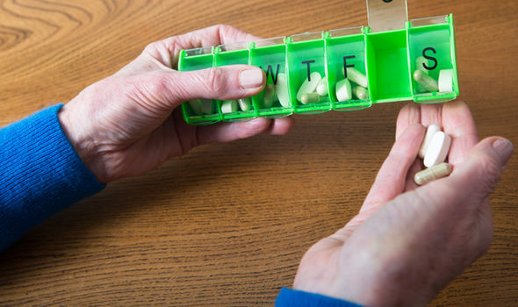GETTY

Sleeping pills: Taking the drugs can increase hip fracture risk

Users can also become dependent on them.

NHS Choices said: “Doctors are usually reluctant to recommend sleeping tablets in the long-term because they just mask the symptoms without treating the underlying cause.”

The results come from a new study by researchers at Cardiff University and King’s College London.

“While ‘Z-drugs are fast becoming the doctor’s hypnotic prescription of choice, there is no evidence that they are a safer alternative to benzodiazepines in relation to hip fracture risk,” said Dr Ben Carter, Cardiff University’s School of Medicine and the Institute of Psychiatry, Psychology and Neuroscience, King’s College London.

“Our study shows that both appear to significantly increase the risk of hip fracture when newly prescribed by doctors.”

A study of people aged over 65 found that new users of these hypnotic medicines experienced nearly two and a half times the fracture rate, when compared with older people not taking hypnotics.

An estimated 53 per cent increase in fracture risk was identified in medium-term users  - 15 to 30 days, as well as a 20 per cent increased risk of hip fracture in long-term users  which scientists classed as greater than 30 days.

Dr Carter added: “Careful consideration of the immediate increased risk of hip fracture should inform the clinical decision-making process.

“Clinically effective measures like strength training to improve frailty, removal of hazards at home, visual correction and a medication review are also needed to mitigate the risk of hip fractures, particularly in the first few days of use.”

The research supports previous studies linking use of hypnotics by older people with an increased risk of accidents, dependence, cognitive decline and hip fracture.

The drugs are also thought to cause drowsiness, delayed reaction times and impaired balance.

The study, called Benzodiazepines, Z-drugs and the risk of hip fracture: A Systematic Review and Meta-Analysis has been published in the journal PLOS ONE.

This comes after it was revealed a [good night’s sleep can fight dementia.](http://www.express.co.uk/life-style/health/662859/Good-night-sleep-fights-off-dementia-memory-loss)